Arizona State University

Network Diagram Analyzer User Guide

CSE 360 Intro to Software Engineering

Fall 208

Anibal Bojorquez

Benedetto Hibler

Vasanti Kasanneni

Jude A. Rayan

**Table of Contents**

Introduction………………………………………………………………………….Page 2

Overview of the Program……………………………………………………………Page 2

Installation…………………………………………………………………………...Page 2

Getting Started……………………………………………………………………....Page 3

User Interface Overview…………………………………………………………….Page 4

Example Runs……………………………………………………………………….Page 5

Restarting…………………………………………………………………………..Page 10

Ending……………………………………………………………………………...Page 10

**Introduction**

This document outlines the main overview of the program. This includes installation, a how-to on getting started, a look into the User Interface, instructions and examples on running the program, and how to restart the program. It is important to read this user guide to understand the functionality of the Network Diagram Analyzer program to get desired results.

**Overview of the Program**

When referencing a network diagram, the Network Diagram Analyzer asks for and uses the activity names, duration of each activity, and a list of dependencies of those activities, to analyze the given network diagram and determine all possible paths in the Network. Along with all the different possible paths in the network, the Network Diagram Analyzer ranks each path in descending order, in terms of duration.

**Installation**

The first step to getting started is installing the source file from Github. Once the source file is installed into your device, getting the program to run is fast and simple. Open the file and run the executable, NetworkDiagramAnalyzer.exe.

**Getting Started**

1. Looking at your diagram, make note of each Activity, and in particular, their names, duration, and their dependents.
2. In the Network Diagram Analyzer program, each entry represents one activity. For each entry, add the name of the activity next to “Name:”, add the duration of the activity next to “Duration, and then add dependents next to “Dependents”.
3. Click Add
4. Do this for as many activities as you have.
5. If you mistakenly add a wrong one, highlight and delete the activity.
6. Once you have added all the activities, you can click the Run button, and it will prompt you to the list with the activities ordered descending by duration.

**User Interface Overview**

Main Menu:

-The table in center screen will display all the Activities you have entered.

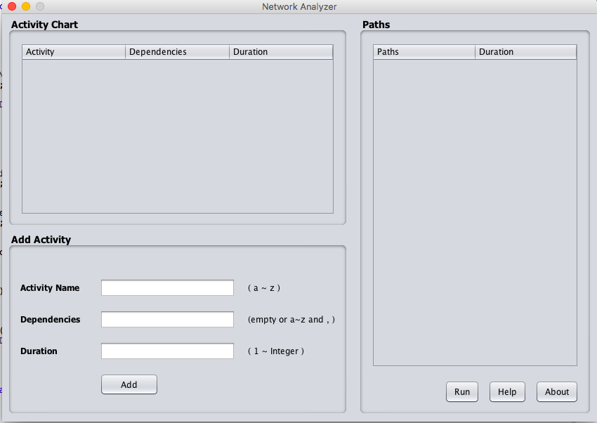

Adding an activity:

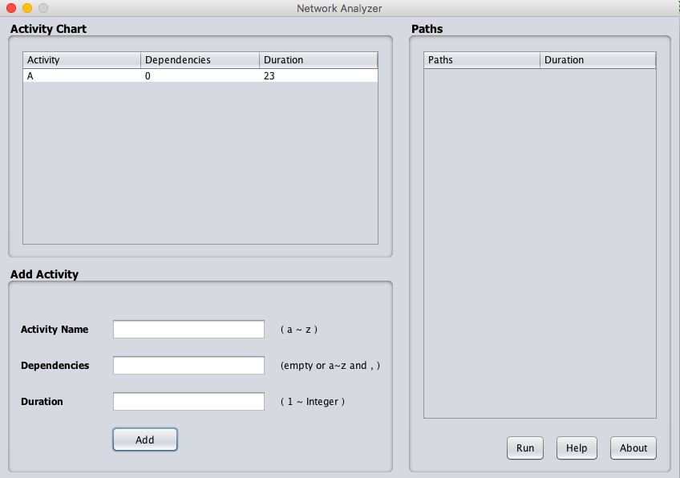

Entering each activity and hitting Run.

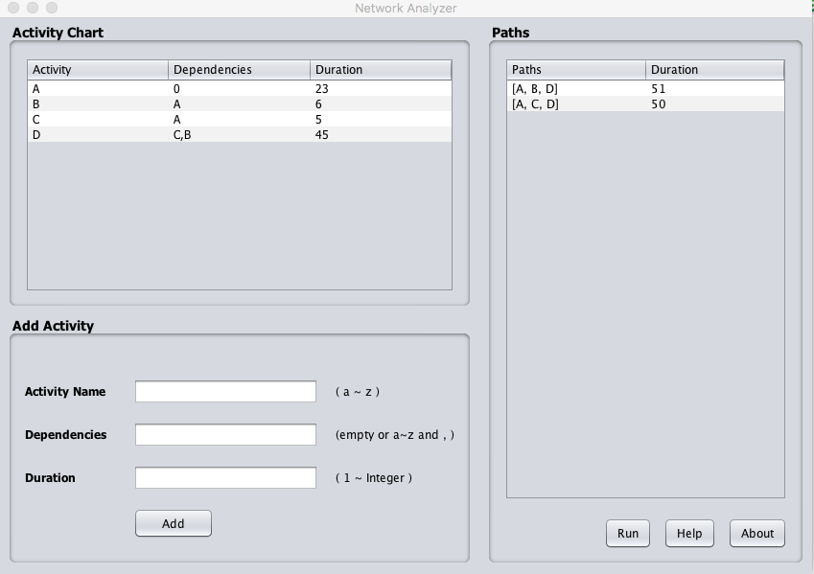

**Example Runs**

* Opening the program will prompt you to this screen.



* You can start adding activities by entering each activity, one by one, in the entry bars at the bottom of the screen

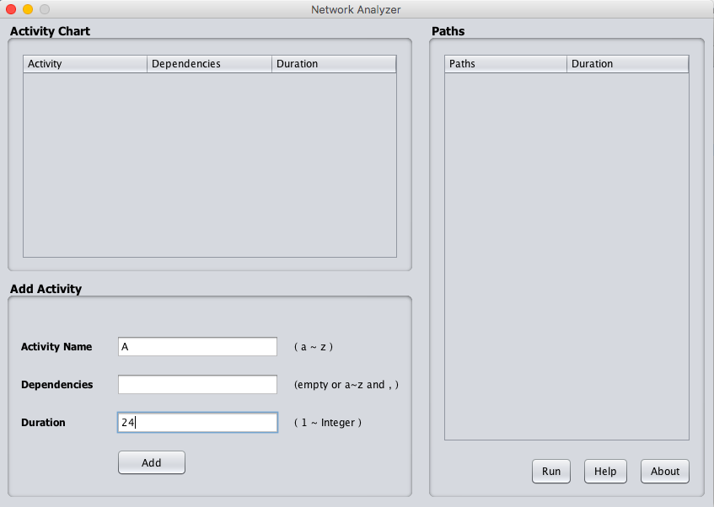

* Hit Add, and the activity will appear on the list. Start adding a new activity in the entry bars.

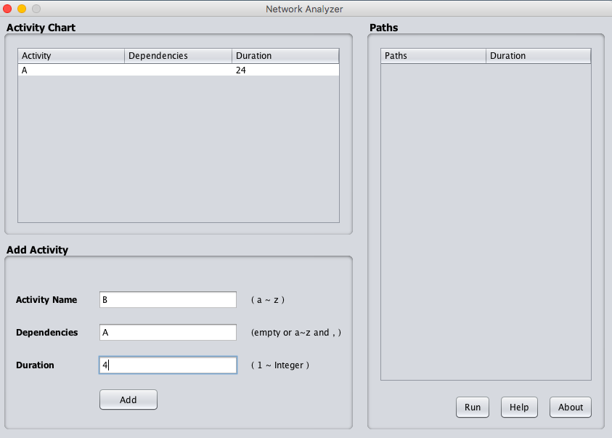

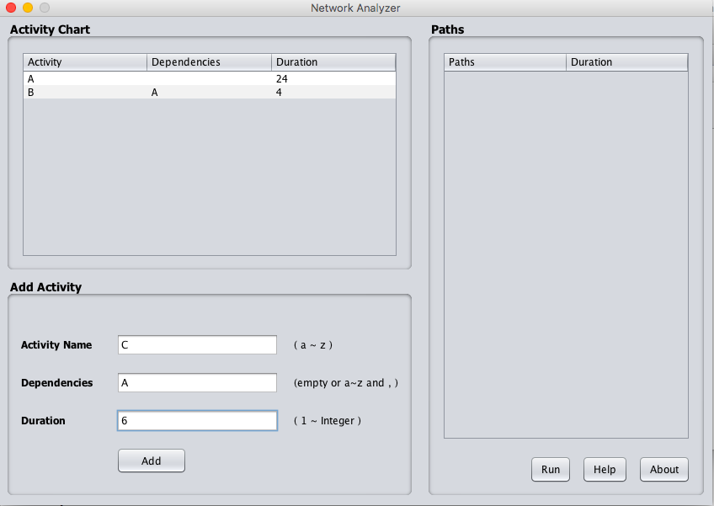

* If an activity has two dependents, separate them with a comma ‘,’.

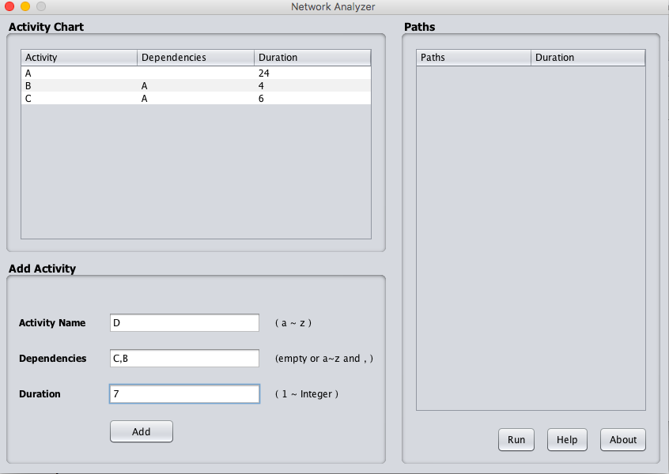

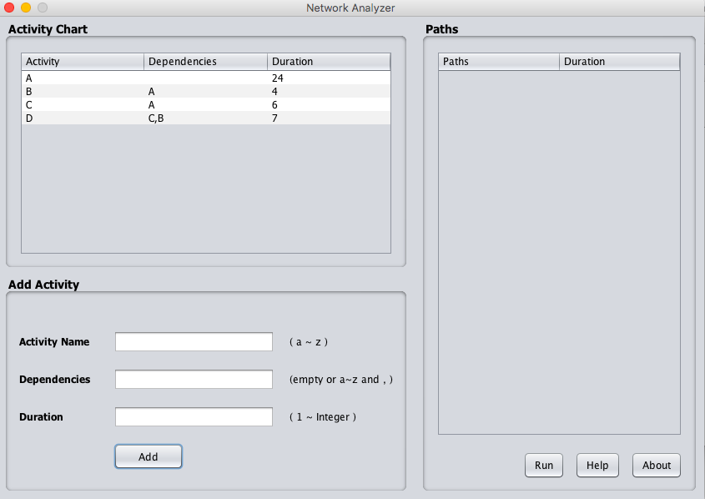

* If you entered one incorrectly or by mistake, highlight the incorrect activity and erase it.

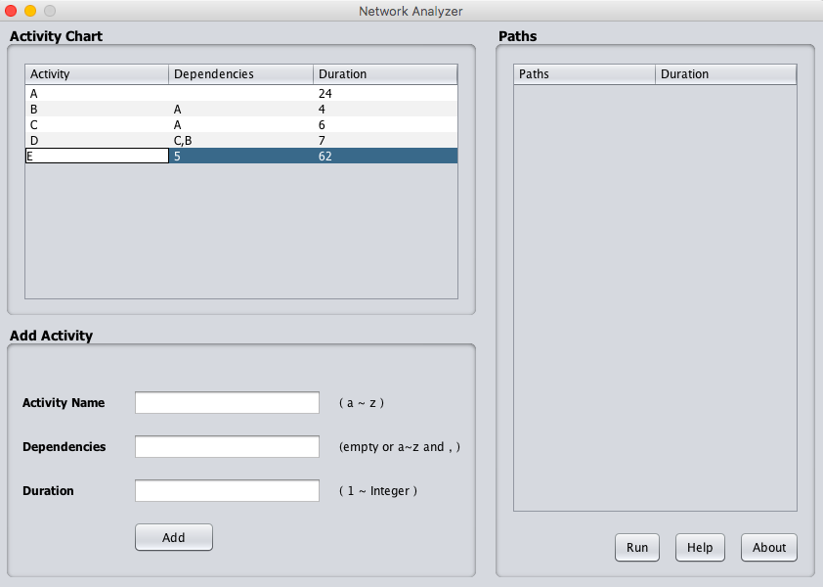



* Hit Run



* Done!

**Examples of Errors**

* Entering a duration that is not an integer

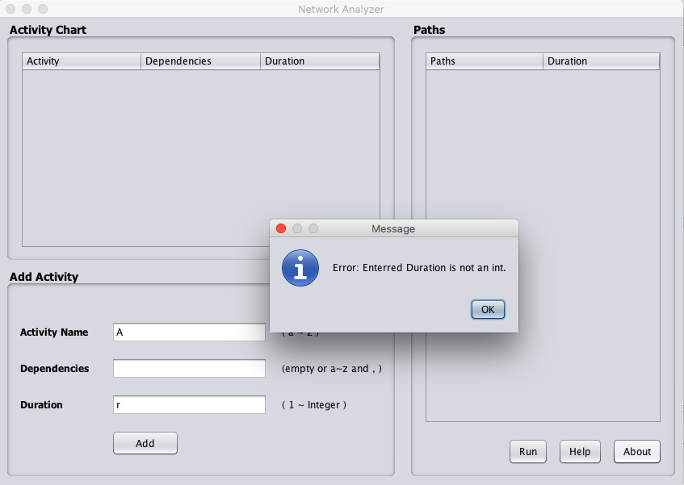

* Entering activities that are not connected

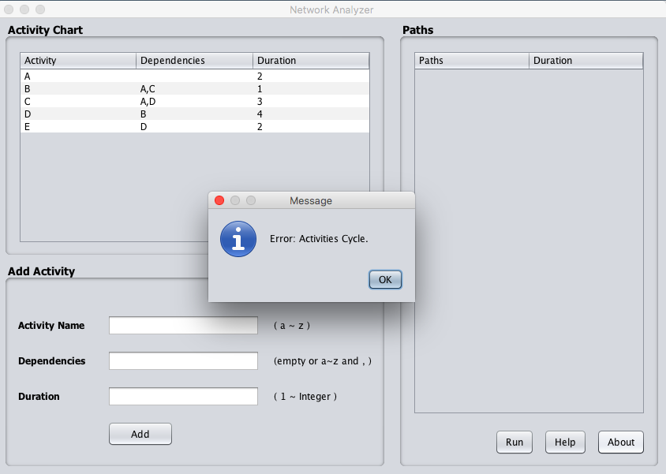

* Entering activities that cycle.



**Restarting**

Restarting the program is simple. The first thing to do is close the program. Once it is closed, you can run start the program and restart.

**Ending**

After you’ve collected all the necessary information you need from the Network Diagram Analyzer, you can close the program by clicking the X icon.